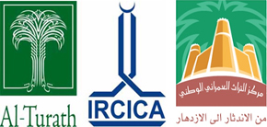

**Al – TurathFoundation**

**Riyadh, Kingdom of Saudi Arabia**

**OIC**

**IRCICA**

**Research Centre for**

**Islamic History, Art and Culture**

**Istanbul, Turkey**

**National Built Heritage Center, SCTH Riyadh, Kingdom of Saudi Arabia**

**ISLAMIC URBAN HERITAGE PROGRAM 2017**

**Spring Training Program**

**2017**

**March 31 - April 08, 2017, JEDDAH**

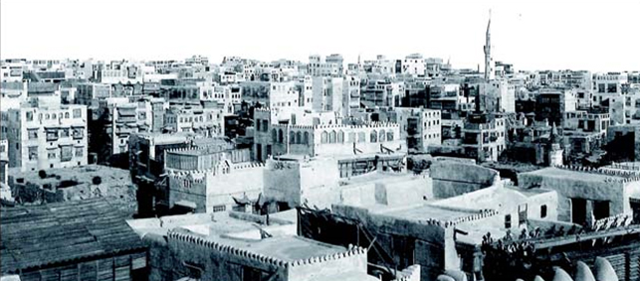

*Historic Jeddah*

[**www.al-turath.com**](http://www.al-turath.com)

[**al-turath@al-turath.com**](mailto:al-turath@al-turath.com)

**&**

**www.ircica.org**

**ircica@ircica.org**

**Al-Turath, IRCICA, National Built Heritage Center**

**ISLAMIC URBAN HERITAGE PROGRAM 2016**

**Spring Training, March 31- April 07, 2017**

**JEDDAH**

***A preliminary Study of the Historic Mosque in Jeddah***

Historic Jeddah, the Gate to Makkah is listed on UNESCO world Heritage list in 2014 (ref 1361) The general strategy for the preservation and revitalization of the area is being drawn by the Saudi Commission for Tourism and National Heritage (SCTH) in coordination with the Jeddah Municipality and the participation of the civil society.



Jeddah is also the gateway for Muslim pilgrims to Mecca who arrived by sea since the 7th century AH when the 3rd Caliph Othman ibn Affan made it the official port of Makkah. The city develops into a thriving multicultural center, characterized by a distinctive architectural tradition, including tower houses built in the late 19th century by the city’s mercantile elites.

Historic Jeddah is an outstanding reflection of the Red sea architectural tradition, a construction style once common to cities on both coasts of the Red sea, built settlements with specific and innovative technical and aesthetic solutions to cope with the extreme climatic conditions of the region (humidity and heat).

The Al-Balad - historic part of Jeddah has great history, architectural qualities, typologies, building materials, decorative pattern, homogeneity and the social and cultural qualities,

Historic Jeddah, the Gate to Makkah is a living urban environment primarily hosting residential and commercial activities, with mosques and charitable structures. The property represents an authentic and traditional urban environment where the headquarters of century old economic enterprises.

The Al-Balad bears a significant testimony to a very specific cultural tradition and to a living civilization. With its traditional mosques Mosque Al-Shaf’i, Mosque al-Mimar, Mosque Othman bin Affan or Mosque Al-Albanus and Mosque Abu Anbah, large houses Beit Nasif, Biet Zenal and Beit Noor wali, schools, charity houses (rabat) Rebat Banajah- Hadhra mouth, Rebat al-khanji Kabir and Saghir and Rebat Al- Maghrabi, trust houses (waqf) historic land marks and springs (ayyun) e.g. Ain Qausiyah.

**1. Mosques:**

There are many old and famous mosques in old Balad area. Examples of a few of the mosques have been given as following:

1. Mosque Al-Shaf’i: This mosque is located near Makkah. It is one of the oldest mosques with beautiful architecture dated 7th AH.
2. Mosque Al-Mimar: located on Souq Al-Al-Alwei, it is also one of the oldest mosques in Jeddah dated 11th or 13th AH. It has a tall minaret with conical shape.
3. Mosque Othman bin Affan or Mosque Al-Albanus (ebony mosque): It is a very small Mosque with a short and new minaret the current building dated 10th AH.
4. Mosque Abu Anbah: This Mosque was a built by a man from the Maghrib who stayed in this Mosque dated 10th AH. He was nick named Abu Anaba.
5. Mosque Al Hanafi one of the historical mosques in historical Jeddah located on Al Dhab road. The Mosque was built in 10th AH or 13th AH.

**2. Houses occupied by Govt. / Govt. representatives including Omadah Houses**

1. Beit Al-Lami
2. Beit Bisiyuni /Baldiya office for the historic Balad district
3. Beit Sayem Al-Dahar
4. Beit Al-Saeemi (Under Govt.)
5. Beit Bakhariba (House for Omadah)
6. Beit Al-Wasiyat (Beit al-Omadah)

**3. Building with special urban value based on urban morphology**

Most of the buildings under this category were belonging to the influential personalities and are located on the trail route and comparatively built with good quality of building materials and have comparatively good architecture. These buildings are located:

* 1. At the center of Al-Balad
  2. Located around the trail routes
  3. Located around the perimeter of the district (edges)
  4. Building with cultural landmark

**These building include:**

* Hotel / Restaurants
* Hospital / Dispensary
* Garden/ Hadeeqah
* Well/ Spring/ Qanwat

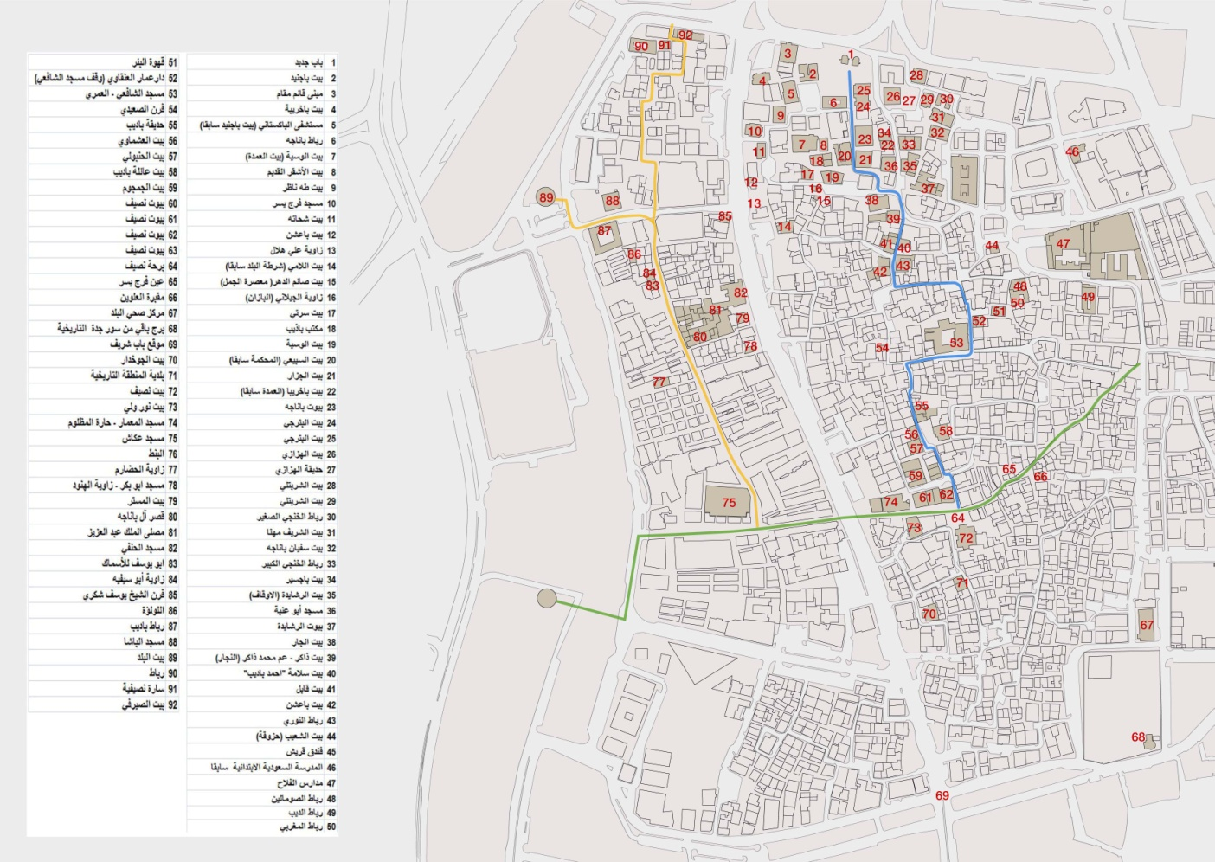

**Methodology:**

Conservation is a process of understanding, interpreting and managing of the architectural heritage in order to protect it for the future generation.

During this training program participants, will go through complete process of conservation of the historic buildings, to be a precise delineation of what survives in terms of buildings and urban plan, as a basis for integrity, and also for future protection and conservation, and a clear understanding of the threshold beyond which integrity would no longer be intact if further buildings were lost.

A Restoration Manual will be used as an integral part of any restoration process in historic cities. The manual is a compilation of different technical process for the restoration of buildings, which includes static and preservation problems and its solution in a most technical manner.

**First part of this process includes following components:**

* Collection of historical data.
* Survey of the Mosques using traditional and computer-laser technology (traditional survey method with technical amenities which include survey with hand devices, total station and laser scanning survey and photography).



* Analyses of buildings' state: construction (foundation, external and internal bearing walls, wall plaster, beams, joist and all the internal details), used materials included all types of doors, windows and even (Timber ties) connecting wooden Beams, which are placed generally in between the coral stone walls, level of deterioration pathologies and causes of deterioration, etc.) and to
* Give a diagnose the specific problem of the building for the conservation purpose.

**Second part of the process includes following components:**

* To restitute original state of the Mosques and finally.
* Prepare conceptual design for rehabilitation of the Mosques.

These studies will be carried out under the supervision of experts in this field:

From Al Turath foundation, IRCICA and National Built Heritage Center as well as the strategic partners.

**Al-Turath, IRCICA, National Built Heritage Center & JEDDAH MUNICIPALITY**

**ISLAMIC URBAN HERITAGE PROGRAM 2017**

**Spring Training, March 31-08 April 2017**

**JEDDAH**

**TIMETABLE**

**Friday, March 31**

Afternoon: Arrival of participants to Jeddah

**Saturday, April 1**

09:00 - 10:00 Registration (in Jeddah)

10:00 - 11:00 Introduction to the program Dr.Osama Al-gohary

11:00 - 01:00 Site visit to historical Jeddah Engineer Sami Nawwar

01:00 - 14:30 Break + Prayer

14:30 – 16:00 Methodology of Restoration and Conservation of Historical Buildings Dr.Amir Pasic

16:00 – 16:30 Break + Prayer

16:30 – 18:30 Structural Problems in Historical Jeddah and Restoration Procedures. Dr.Sameh Abdelsalam

18:30 – 19:00 Break + Prayer

19:00 – 20:00 Methods of Documentations of Historic Building Dr Amir Pasic

**Sunday, April 2**

09:00 – 11:00 LASER scanning technology and its application in documentation of historical buildings Eng. Alija Botic

11:00 – 13:00 Site training on application of 3D LASER scanning in documentation of historical buildings Eng. Alija Botic

13:00 – 14:30 Break + Prayer

14:30 – 16:00 Manual Documentation for Historic Buildings

16:00 – 16:30 Break + Prayer

16:30 – 18:30 Studio Work

18:30 – 19:00 Break + Prayer

19:00 – 20:00 Studio Work

**Monday, April 3**

09:00 – 11:00 Methodology of restoration and conservation of historical buildings Prof.Dr. Saleh Lamie

11:00 – 13:00 Conservation project of Alshafie and Almamar Mosques Prof.Dr. Saleh Lamie

13:00 – 14:30 Break + Prayer

14:30 – 16:00 Site visit to Alshafie mosque and Almamar Prof.Dr. Saleh Lamie

16:00 –16:30 Break + Prayer

16:30 – 18:30 Studio Work

18:30 – 19:00 Break + Prayer

19:00 – 20:00 Conservation project in Cyprus Prof.Dr. Saleh Lamie

**Tuesday, April 4**

09:00 – 11:00 Practical site work

11:00 – 13:00 Studio Work

13:00 – 14:30 Break + Prayer

14:20 – 16:00 Studio Work

16:00 – 16:30 Break + Prayer

16:30 – 18:30 Studio Work

18:30 – 19:00 Break + Prayer

19:00 – 20:00 Studio Work

**Wednesday, April 5**

09:00 – 11:00 Methodology of Restoration and Conservation of Historical Buildings Arch. Fouad Serrghini

11:00 – 13:00 Practical example of Preservation and conservation of Bab El Guissa Mosque

13:00 – 14:30 Break + Prayer

14:30 – 16:00 Studio Work

16:00 –16:30 Break + Prayer

16:30 – 18:30 Studio Work

18:30 – 19:00 Break + Prayer

19:00 – 20:00 Architecture in Morocco good examples

**Thursday, April 6**

09:00 – 11:00 Studio Work

11:00 – 13:00 Studio Work

13:00 – 14:30 Break + Prayer

14:30 – 16:00 Studio Work

16:00 – 16:30 Break + Prayer

16:30 – 18:30 Studio Work

18:30 – 19:00 Break + Prayer

19:00 – 20:00 Studio Work

**Friday, April 7**

16:00 – 18:30 Presentations for student's projects

18:30 – 19:00 Break + Prayer

19:00 – 20:00 Discussions

**Saturday, April 8**

14:30 – 16:00 Final Presentations

16:00 – 18:30 Closing Ceremony

**Students asked to bring their laptops and drawing tools \*\*\*\***

**THE PARTICIPATION CERTIFICATE**

Participants who successfully complete the program will be awarded a Certificate issued and signed by the organizers: Research Centre for Islamic History, Art and Culture (IRCICA, Istanbul), Al-Turath Foundation.

**THE SPRING PROGRAM PERIOD AND DATES**

The Spring Program will begin on Saturday March 31 2017 and end on Saturday April 07, 2017, with work in offices, work on construction sites, evening lectures and panels and weekend field trips.

**Working language**

English / Arabic

**PROGRAM FEE:** The Program fee is **1250 SAR** per student for Lectures tuition only.

**NO TUITION FEE FOR THE FULL PROGRAM**

Field trips transportation, lodging in a double room, daily meals, and course materials will be arranged by the participate students. Al-Turath will provide the lectures the place for the lectures and needed equipment’s for the demonstrations.

**Program Coordinators**

|  |  |
| --- | --- |
| G:\01 AP Personal\01-AP CV\001 AP ID\amirphoto 11.jpg | **DR. OSAMAH MOHAMMED NOOR ABDALLAH EL-GOHARY**  **1984: Ph.D. University of Pennsylvania, Philadelphia, PA, USA.**  **1980: M.A. /M.Sc. University of Pennsylvania, Philadelphia, PA, USA.**  **1976: M.A. /M.Sc. Univ. of Notre Dame, College of Arch. & Planning: South Bend, IN, USA.**  **1974: M. Arch (Louis Khan Studio) Univ. of Pennsylvania, Philadelphia, PA, USA.**  **1972: B.Sc. University of Riyadh, KSU College of Engineering, Dept. of Architecture. Riyadh, KSA.**  **Areas of Specialty:**  **Theory and History of Architecture; Islamic Art and Architecture**  **Research Areas/ Interests:**  **Traditional Architecture; Mosque Architecture; Islamic Architecture**  **2013 to 2015: Manager of the Architecture Studies for Historic Building, corridor and Path ways, in Historic Jeddah.**  **Secretary General of Al-Turath Foundation.** |

|  |  |
| --- | --- |
| G:\01 AP Personal\01-AP CV\001 AP ID\amirphoto 11.jpg | **Dr. AMIR PASIC**  **Professor of architecture (1999), urban planning (2000), and theory and history of architecture and historic preservation (2009) and the Consultant to Director general of the Research Centre for Islamic History, Art and Culture (IRCICA), Istanbul (since 1993).**  **Currently he is affiliated with the University of Sarajevo as the head of the Doctorate Program in Architecture. Also, he was lecturing at more than 30 universities worldwide.**  **He is the recipient of the Aga Khan Award for conservation of the Old Town of Mostar (1986), and five other architectural awards. He served as the leading consultant for the Aga Khan Trust for Culture, Geneva (1995-2006); the World Monuments Fund, New York (1998-2004); and made a several missions for ICOMOS Paris. He is member of National Commission to Preserve National Monuments of Bosnia and Herzegovina since January 2016,**  **The author of 67 realized restoration or rehabilitation or reconstruction and contemporary-design projects of different size and four urban preservation plans. The author or co-author of 16 books and 35 articles related to preservation of urban and architectural heritage, and also author of the Nomination dossier for the World Heritage property “Old Bridge Area of the Old Town of Mostar“(2005).** |

**Program Lecturers**

|  |  |
| --- | --- |
|  | **PROF. DR. SALEH LAMEI**  **Director General CIAH**  **Prof. Saleh Lamei born in 1935 in Cairo.**  **Bsc. in Architecture from Ain Shams University; Cairo, Egypt, in 1956.**  **Dipl. -Ing. Aachen University, Germany, in 1963.**  **Dr.- Ing. from the Technical University Aachen , Dept. Germany, 1966**  **Professor for Islamic Architecture and Restoration, Arab University, Beirut Lebanon, 1976-84. Dean of school of Architecture 1982-84.**  **Consultant of Organization of Islamic Capitals and Cities for Islamic Urban and Architecture, 2003. Representing Egypt in The Arab Supreme Council for Cultural Heritage, 2004***.*  **He became a member of the UNESCO International Committee for the Preservation of the Cultural properties, Old City of Jerusalem.**  **Since 1984 Prof. Lamei is the general Director of the Centre for Conservation & Preservation of Islamic Architectural Heritage. in the domain of Islamic Architecture & restoration (register No.350 at the Egyptian Engineering syndicate) .Prof. Lamei is a former member of the Egyptian National Committee of ICOMOS and member of ICOMOS International Executive Committee (Paris), from 1993 until 2002.He was awarded six awards from different International and Arab Organizations Beside his publications in Arabic, he published in English, and German too.**  **Prof. Lamei supervised many M. A. & P.H.D. dissertations in Egyptian & Foreign Universities. He was also visiting Professor at different Arab and Foreign Universities.** |

|  |  |
| --- | --- |
| سامح | **ARCH. FOUAD SERRHINI**  **Graduated National School for Architecture in Rabat - Morocco 1990-1984**  **General Director of (ADER-Fes)**  **Urban Planner**  **Specialist on Preservation and Restoration (Morocco).** |

|  |  |
| --- | --- |
| C:\Users\DELL\Downloads\Scan.jpg | **ENG. SAMI SALEH MAHMOUD NAWAR**  **Manager, Urban Heritage and Head of the Municipality of Historic Jeddah.** |

|  |  |
| --- | --- |
| سامح | **DR. SAMEH ABDUSALAM ABBAS**  **Obtained master degree in in restoration and conservation 2007and PhD in 2011 in restoration and preventive conservation from Cairo university ,worked in American research center in Egypt in restoration projects in historic Cairo, SCA conservation projects in Egypt, worked for SCTH restoration project in Feed, worked for Eight years in AL-Turath foundation, conservation projects in KSA, lecturer in several conferences , presented many papers in restoration and conservation current position deputy manager for architectural and conservation studies in historic Jeddah.** |

|  |  |
| --- | --- |
| G:\01 AP Personal\01-AP CV\001 AP ID\amirphoto 11.jpg | **MR. ALIJA BOTIC**  **Academic Qualifications:**  **Specialization for RIEGL 3D laser scanning and modeling, Wienn, Austria 2010**  **Specialization for KONICA-MINOLTA 3D laser scanning and modeling, Munchen, Germany 2002**  **Specialization for LEICA 3D laser scanning and modeling, Den Hag, Denmark 2000**  **Surveyors**  **Banja Luka Bosnia & Herzegovina**  **Professional Affiliation:**  **Member of Surveyors Association of Bosnia and Herzegovina**  **Adviser for 3D laser scanning at the institute LGA, Nunberg, German**  **Professional Qualification: Laser scanning expert.** |